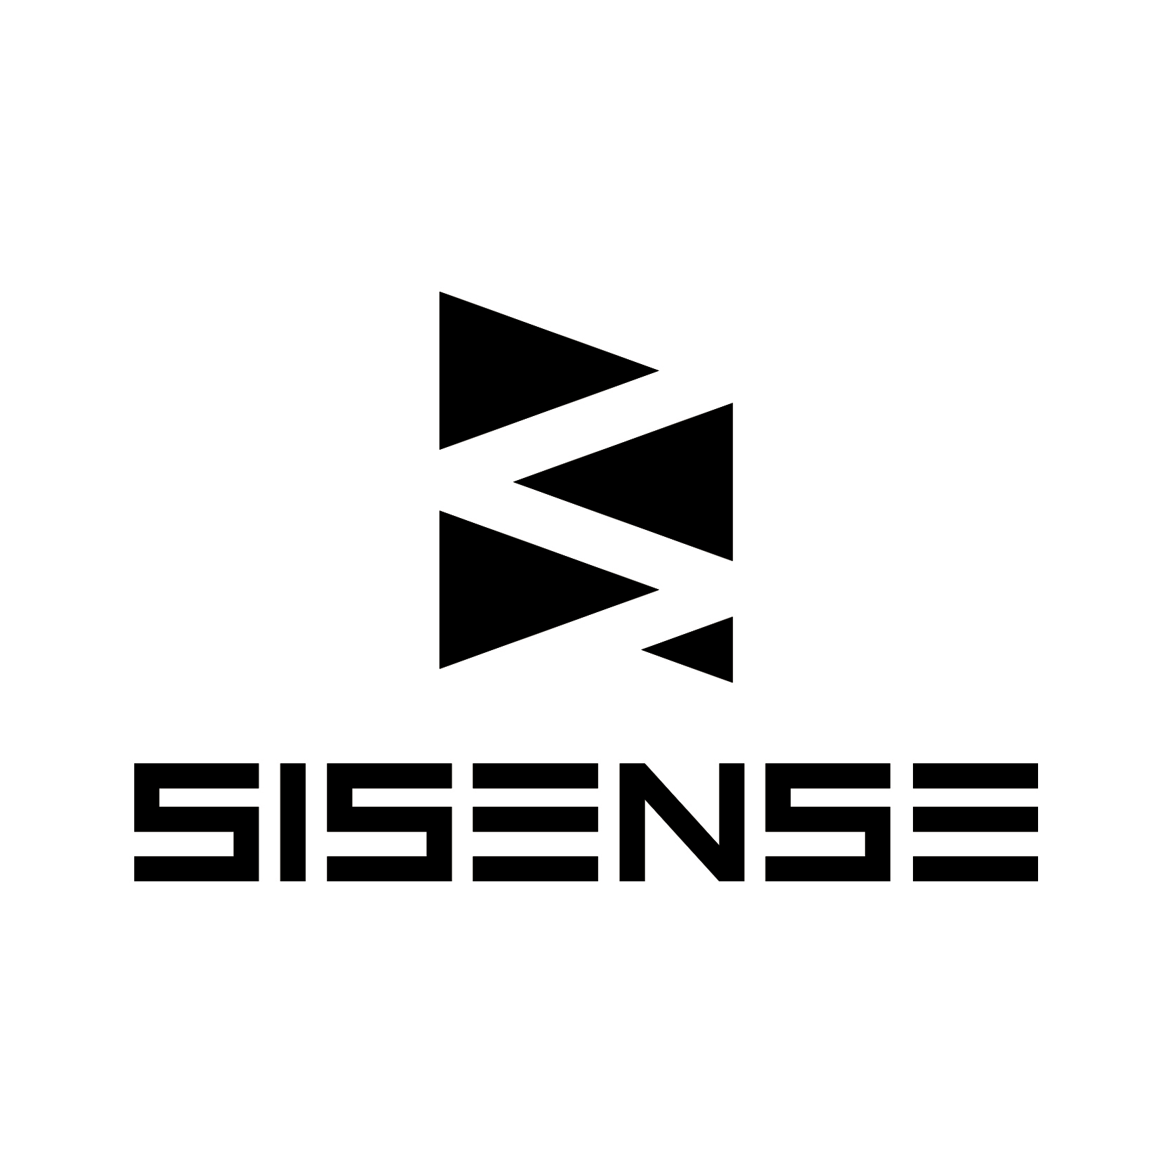

Company Fact Sheet

Company Overview
Sisense is simplifying business analytics for complex data. Hundreds of companies, from startups to large enterprises, are choosing Sisense technology over traditional solutions. Sisense enables non-technical business users to manage, analyze and visualize growing data sets from a multitude of disparate data sources. Powered by its unique In-Chip™ and Single-Stack™ technologies, Sisense delivers unmatched performance, agility & value. With customers in 50 countries, including global brands like Target and Samsung, Sisense is revolutionizing the business analytics market. The Company was positioned in Gartner’s 2016 Magic Quadrant for Business Intelligence and ranked “top 2” for business benefit achieved, ease of use, and customer renewal. The company was also recognized was also recognized as an “Overall Experience” and “Credibility” leader in Dresner’s 2016 “Wisdom of Crowds” BI market survey. In 2015 Sisense received numerous awards, including ranking 47th among the Deloitte Technology Fast 500 EMEA; Ventana Research’s 2015 Information Technology Innovation Award for Business Intelligence; Frost & Sullivan’s Customer Value Leadership Award for BI; and Celestica’s Total Cost of Ownership Supplier Award. Sisense was designated a hot company to watch by CIO, CRN and Information Management and recognized as one of the “10 Most Innovative IT Ventures” at Under the Radar. Its solution won the “Audience Choice” award at the O’Reilly Strata conference and its CTO won the World Technology Award for the invention of In-Chip analytics.

For more information, visit www.sisense.com
For images and press kit materials

Fast Facts
- Investors: Bessemer Venture Partners, DFJ Growth, Battery Ventures, Opus Capital, Genesis Partners
- U.S. Headquarters: New York, NY; R&D Center: Tel Aviv, Israel
- 250+ employees
- Growing 100%+ for five consecutive years
- Customers in 50 countries
  - Case studies here
- Company History
  - 2004 – 2010 Research & Development
  - 2010 -- Series A Round $4M; Solution sales begin
  - Fall 2012 – Official Launch
  - April 2013 – Series B Round $10M (details here)
  - June 2014 – Series C Round $30M (details here)
  - January 2016 – Series D round $50M (details here)

Awards and Recognition
- Dresner Overall Experience and Credibility leader in Wisdom of Crowds BI Survey 2016
- Gartner MQ for Business intelligence, 2016
- Stevie Awards Bronze Winner, Company of the Year - Computer Software, 2016
- CODiE Awards finalist in Best Business Intelligence Tools & Platforms, 2016
- Named Top Rated BI platform by TrustRadius
- Ranked 47th among the Deloitte Technology Fast 500 EMEA
- Ventana Research’s 2015 Information Technology Innovation Award for Business Intelligence
- Frost & Sullivan’s Customer Value Leadership Award for BI
- Celestica’s Total Cost of Ownership Supplier Award
- Named one of top tech startups to watch by WSJ, Feb 2015
- Named Top Rated BI platform by TrustRadius,
- Deloitte Israel Technology Fast 50: Rising Star, September 2014
- Gartner Cool Vendors in Analytics 2014, June 2014
- GigaOM Sector Roadmap Data Discovery, March 2014
- Gartner Magic Quadrant for Business Intelligence and Analytics Platforms – mention as “Interesting Vendor”, February 2014
- Forrester’s 10 Step Methodology for Shortlisting BI Vendors
- Winner, Take the H.E.L.M. Competition identifying most promising startups in NYC, November 2013 - $250,000 award
- World Technology Awards November, 2013
  - Winner, IT Software (Individual) - CTO & Co-founder, Eldad Farkash
  - Finalist, IT Software (Corporate) – Sisense (the company)
- Frost & Sullivan New Product Innovation in the North American Cloud based Big Data Analytics Platform Market - 2013
- CRN, “10 Coolest Big Data Startups of 2013” – July 2013
- CIO, Top 10 Big Data Startups to Watch (July 2013); Hot Big Data Company to Watch (June 2013)
- Under the Radar, 10 Most Innovative New IT Ventures – May 2013
- Frost & Sullivan, 2013 North American New Product Innovation of the Year Award – April 2013
- CRN Big Data 100 – April 2013
- O’Reilly Strata “Audience Choice” Award – February 2013
- CRN “Ten Things to See at Hadoop World” – December 2012
- CRN “Hot Product to Watch at Dreamforce” – September 2012
- Information Management “Vendor We’re Watching” – September 2012
- Recent Coverage

Technology
Sisense is powered by its In-ChipTM and Single-StackTM technologies, Sisense allows non-technical users to analyze 100 times more data at at-least 10 times the speed of current in-memory analytics solutions. There’s no need to set up complex data warehouse systems or OLAP cubes. And there’s no need for coding or scripting, regardless where data comes from or how big it is.

Management
- Amir Orad, Chief Executives Officer
- Eldad Farkash, Co-founder and CTO
- Todd Sloan, CFO
- Saar Bitner, VP Marketing
- Jordan Christopher, VP Sales
- Keren Myr, VP Sales EMEA
- Leon Gendler, VP R&D and Delivery
- Gali Kedar, VP Customer Success
- Jeremy Sokolic, VP Product Marketing
- Aviad Harrel, VP OEM & Field Engineering
- Ronen Fischler, Chief Business and Corporate Development

Founders
- Eldad Farkash
- Elad Israeli
- Adi Azaria
- Guy Boyango
- Aviad Harell
Social Channels
Follow Sisense on: LinkedIn, Twitter, Facebook, Blog, YouTube

Media Contact:

PAN Communications
Marki Conway
+1 (617) 502-4300
sisense@pancomm.com
Jeremy Sokolic
Sisense
+1 (646) 432-1507
pr@sisense.com

